NOTICE OF REQUEST FOR PROPOSALS

This Notice, dated April 21, 2026, is provided to those firms who have successfully been qualified as the result of the Application for Qualification process completed by CORE Construction (CORE), and approved by Nye County School District (“NCSD”). In compliance with the requirements of NRS 338.16995, the following list of trade subcontract scopes of work are estimated to equal or exceed $120,000 (1% of the Project Budget, or $50,000, whichever is greater), and must follow the statutory requirements for the receipt of subcontractor proposals:

- Bid Package #002 – Abatement & Building Wrecking
- Bid Package #008 – Site Demolition, Salvage, Earthwork, Asphalt Paving, Wet Utilities, & Site Signage & Striping
- Bid Package #016 – Landscaping & Irrigation
- Bid Package #021 – Running Track Surfacing
- Bid Package #022 – Synthetic Turf Sports Field
- Bid Package #023 – Fencing & Gates
- Bid Package #030 – Concrete
- Bid Package #031 – Masonry
- Bid Package #033 – Structural Steel & Ornamental Metals
- Bid Package #045 – Metal Roofing, Fascia & Soffit Panels
- Bid Package #060 – Framing, Drywall & Painting (incl. FRP)
- Bid Package #094 – Bleachers & Press Box
- Bid Package #098 – Plumbing Systems
- Bid Package #100 – HVAC & Building Control Systems (incl. Test & Balance)
- Bid Package #103 – Electrical & Low Voltage Systems (incl. Sports Field Lighting)
- Bid Package #109 – Prefabricated Ticket Booth

SUBMISSION OF PROPOSALS
Proposals will be received electronically through Building Connected before 1:00 PM PDT on Tuesday, May 12, 2026.

Submit the following required documents, arranged in order, in a single PDF file:

- CORE Subcontractor Proposal (Bid) Form, including Tier Subcontractor listing and Acknowledgements;
- Subcontractor formal proposal on company letterhead that lists any and all inclusions, exclusions, clarifications, and Voluntary Alternates; and
- Should a Subcontractor elect to obtain a Single Project Limit Increase from the Nevada State Contractors Board, Subcontractor shall include a copy of the fully executed Approval with its Proposal.

Subcontract Proposals shall be submitted on the CORE-provided form and in the manner stipulated. No editing or alterations of the Subcontract Proposal Form shall be allowed. Any deviations from these procedures may cause Subcontractor’s Proposal to be deemed non-responsive and rejected. Please be notified that all proposals must be verified for responsibility, responsiveness, and qualifications. As such, all proposals shall be taken under advisement pending review by NCSD and CORE Construction.

Please be aware that the Building Connected system will lock-out at precisely at 1:00 PM PDT on Tuesday, May 12, 2026. Bids not fully entered and confirmed by that time will fail in the system. (Subcontractors are advised to begin the submission process no later than noon on this date.)

Proposals will be downloaded privately from the Building Connected system for evaluation at office of CORE Construction in the presence of Nye County School District personnel on Tuesday, May 12, 2026.

DESCRIPTION OF THE PROJECT

The overall NCSD Tonopah High School Sports Complex project consists of:

Selective site demolition including existing running track surfacing, synthetic turf sports field, fencing and gates, grandstands/bleachers, press box, and concessions building. Salvage of select existing equipment is required, including sinks at concessions kitchen, flag, irrigation equipment, and A/V equipment.

New site work consists of earthwork; asphalt paving; wet and dry utilities; concrete flatwork; irrigation; synthetic turf sports field; running track surfacing; storm drainage system including linear drains at inside track curb; fencing & gates, including discuss cage; exterior athletic (Track & Field) equipment; grandstands with integral walking platform, stairs, and accessible ramp; press box; scoreboard; prefabricated ticket booth; site furnishings; sports field lighting; and flagpole. Waterproofing/damproofing, site caulking and sealants, and site painting are required.

New Concessions building construction consists of structural concrete foundations & slab-on-grade; masonry; steel joists & decking; metal roofing & fascia panels; overhead coiling doors; hollow metal doors, frames & hardware; framing & drywall; insulation; acoustical ceilings; painting & coatings; epoxy flooring; finished concrete; (warming kitchen) food service equipment; lockers; marker boards & menu display case; signage; restroom & fire protection specialties; and Plumbing, Mechanical, Electrical & Low Voltage systems. Electrical and Low Voltage systems to be tied back to existing High School ER/TR.

The overall NCSD Tonopah Elementary School Demolition work (also under this project) consists of:

Demolition at abandoned elementary school campus includes hazardous materials abatement & full building wrecking of abandoned school buildings at a remote location, located at 1220 Idaho Circle, Tonopah, NV. Safe-off and demolition of existing secondary power feeders; demolition and replacement of existing propane tank; demolition of select site finishes and amenities; and new fencing and gate are also required at this site. Excavate below grade, cut, cap & bury existing wet utility stub ups at existing slabs-on-grade to remain. Salvage and reinstall existing exterior canopy columns, including new connections to existing canopies to remain. Demo existing trees and shrubs, including stump grinding. Cut and cap existing water and propane piping.

The total construction budget is estimated at $12,000,000.

PROJECT DOCUMENTS

Qualified subcontractors may obtain project documents at the following address:

https://core.egnyte.com/fl/dBBYFXhTDtQc/Bid_Documents_(THS_Sports_Complex)_04.21.26_

Project Documents included in this link:

- 01 – Notice of Request for Proposal
  - Notice of Request for Proposals (1%)
  - Invitation to Bid (Non-1%)
- 02 – Subcontractor Trade Scopes of Work
  - Subcontractor Trade Scopes of Work
  - Subcontractor Proposal (Bid) Form (1%)
- 03 – Construction Documents
  - Bid Set Drawings
- 04 – Project Specification Manual
  - Bid Set Specifications
  - Surveys & Reports
- 05 – Supplemental Documents
  - CORE Subcontract Agreement template
  - Insurance Requirements
  - Billing Procedures
  - Textura Enrollment Information
  - Affidavits of Compliance
  - Preliminary Construction Schedule
- 06 – Clarifications & Addenda
  - (TBD)
QUESTIONS / RFI’S

All questions and RFI’s shall be submitted to CORE Construction not later than Wednesday, April 29, 2026 to allow sufficient time for responses prior to the proposal due date. Submit RFI’s through the message function of Building Connected.

PRE-PROPOSAL MEETING / SITE VISIT

The project is to be constructed on an active school campus which will remain active for the duration of this contract. Demolition work will take place at an active school administration campus. A mandatory pre-proposal meeting / site visit is not scheduled for this Project: however, Subcontractors wishing to visit either site may do so by checking in and out with the respective front office. Subcontractors failing to check in or out with the school(s) office(s) may be deemed non-responsive.

The Project site is located at:

Tonopah High School
1 Ray Tennant Wy, Tonopah, NV 89049
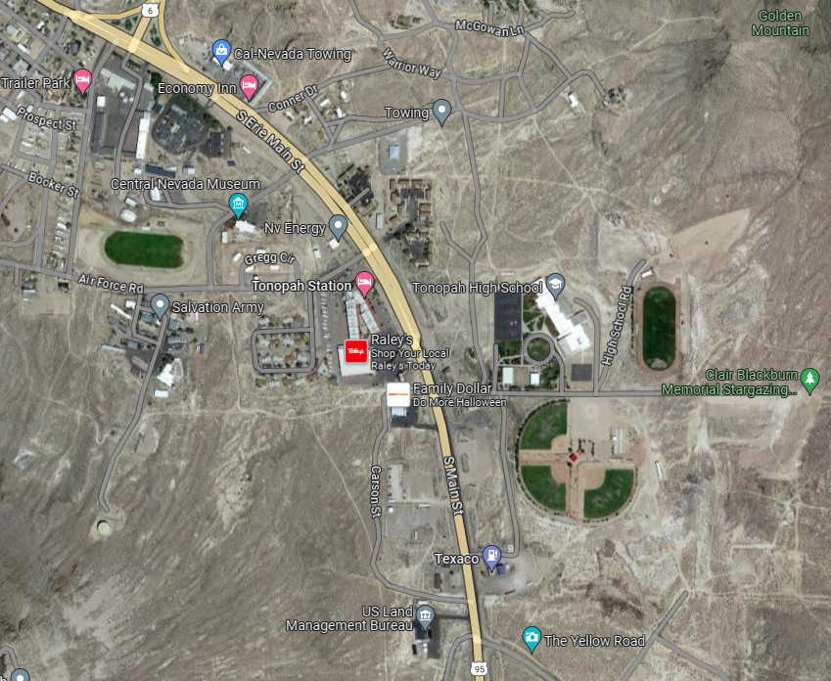

ABANDONED Tonopah Elementary School (to be demolished)
1220 Idaho Cir, Tonopah, NV 89049
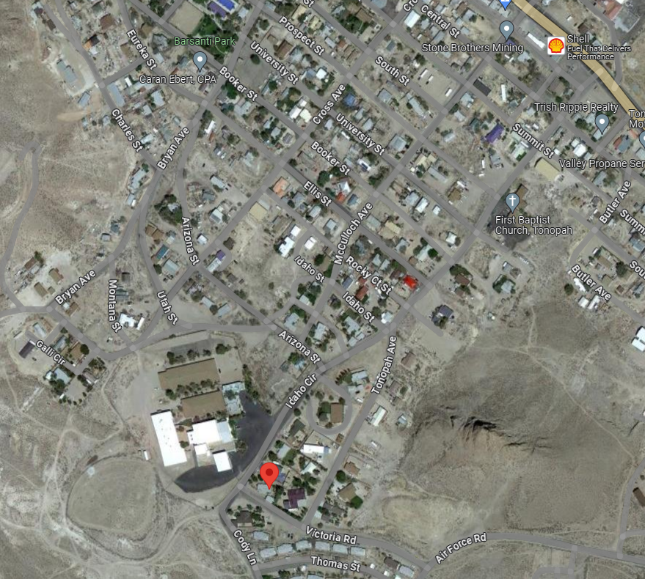

CONSTRUCTION TIMELINE

It is anticipated that an Administrative Notice to Proceed will be issued by the Owner on or about July 20, 2026 for shop drawings and submittals. Construction Notice to Proceed will be issued on or about November 23, 2026 (at the end of the 2026 Football Season). Sport Field completion will be on or about July 26, 2027 (before the start of the 2026 Football Season). Project completion will be on or about October 2026. See Preliminary Construction Schedule for more information.
INSURANCE REQUIREMENTS

See Insurance Requirements (subfolder 05 – Supplemental Documents).

BONDING REQUIREMENTS

Payment and Performance Bond is not required as part of Base Bid Proposal. Subcontractor shall provide additive Alternate for the value of a Payment and Performance Bond as required on the CORE Subcontractor Proposal (“Bid”) Form. Subcontractor shall list Payment and Performance Bonding Rate on the CORE Subcontractor Proposal (“Bid”) Form (required).

TEXTURA ENROLLMENT

CORE Construction uses Textura Construction Payment Management (CPM), an online invoicing and payment management tool. If awarded the project, you will be required to enroll in Textura in order to receive payment. Please refer to the Project Documents for information regarding enrollment fees. Subcontractor shall list include Textura fee in bid proposal.

PREVAILING WAGES

This project is subject to the most current prevailing wage rates. Subcontractors are responsible for using the correct wage rates for their proposals. Southern Nevada Rural Region prevailing wage rates, including zone pay, if applicable, for this Project may be accessed at the following address:

https://labor.nv.gov/uploadedFiles/labornvgov/content/PrevailingWage/Southern%20Nevada%20Rural%20Region%202025-2026-Amendment%2001.pdf

NEVADA REVISED STATUTES*

NRS 338.16995* paragraph 4.i requires the following statements to be included in this Notice of Request for Proposal.

Notice: For a proposal for a subcontract on the public work to be considered:

- The subcontractor must be licensed pursuant to Chapter 624 of NRS;
- The proposal must be submitted on the form provided by the construction manager at risk and be timely received;
- If a preproposal meeting regarding the scope of the work to be performed by the subcontractor is held, the subcontractor must attend the preproposal meeting; and
- The subcontractor may not modify the proposal after the date and time the proposal is received.

Paragraph 6 states that to be considered responsive, a proposal must:

- Be submitted on the form provided by the construction manager at risk pursuant to subsection 3;
- Be timely received by the construction manager at risk; and
- Substantially and materially conform to the details and requirements included in the proposal instructions and for the finalized bid package for the public work, including without limitation, details and requirements affecting price and performance.

NRS 338.0117* paragraph 1 requires the following of bidders receiving preference in bidding:

- [Submit] a signed affidavit which certifies that, for the duration of the project, collectively, and not on any specific day:
  - At least 50 percent of the workers employed on the public work, including, without limitation, any employees of the contractor… and of any subcontractor engaged on the public work, will hold a valid driver’s license or identification card issued by the Department of Motor Vehicles of the State of Nevada;
  - All vehicles used primarily for the public work will be:
    - Registered and partially apportioned to Nevada pursuant to the International Registration Plan, as adopted by the Department of Motor Vehicles pursuant to NRS 706.826; or
    - Registered in this State;

SPECIAL PROVISIONS – APPRENTICESHIP UTILIZATION ACT (SB 82)*

Senate Bill (SB) 82 stipulates requirements for Apprenticeship Utilization on public works projects:
https://legiscan.com/NV/text/SB82/2023

* It remains the Subcontractor’s responsibility to be familiar and compliant with the entirety of this and all other relevant statutory and legislative requirements.

DISCLAIMER

Nye County School District and CORE Construction reserve the right to accept or reject any or all proposals and to waive irregularities in the proposal process and accept the proposal which is determined by Nye County School District and CORE Construction to be in their best interest. Nye County School District and CORE Construction are equal opportunity employers and will not knowingly discriminate in any area of employment Nye County School District CORE Construction invite all businesses which include women-owned, minority-owned, and disadvantaged business enterprise companies to participate in the proposal process.

END OF NOTICE OF REQUEST FOR PROPOSAL

